1. Tables - colspan

Golden petals is one of the most popular event managing company in Mumbai. The company would always have a resemblance with the Indian traditional management skills. They wanted to be different from all others in the society.  
  
Many events are going to be organized for the public sectors like TATA Motors, Award function by BEA tv etc,. Ayush, the Chairman of that company wanted to review the list of events that are being planned for this year. The task to create an html web page has been assigned to Manohar from the development team. The web page should have the list of scheduled events. The page has some unknown start and end time of the event scheduled. In this situation, he could not do it alone. Hence , he needs your help to complete this work   
  
Let us help him to create the schedule list using colspan attribute in the table.

Hints :

Attribute colspan

The colspan attribute defines the number of columns a cell should span.

Syntax :

<table>

<tr>

<th>column 1</th>

<th>column 2</th>

</tr>

<tr>

<td>colspan='1'</td>

<td>colspan='1'</td>

</tr>

<tr>

<td colspan="2">colspan='2'</td>

</tr>

</table>

The webpage will looks like below,

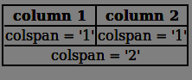

Content :

h2 tag - Event Schedule

|  |  |  |  |
| --- | --- | --- | --- |
| **Name** | **Venue** | **Start Time** | **End Time** |
| Corporate Events | RVS Hall, 3rd Floor | Yet to start | |
| Wedding Planning | Sri Plus Thirumana Mahal | 1.1.2019 7.00AM | 1.1.2019 9.00AM |
| Product Launches | RVS Hall, 2nd Floor | Yet to start | |
| Seminor on Cloud Computing | Vivekanandha Auditorium | Yet to start | |
| Heavenly Fashion | Bath Record Office | 21.3.2018 5.00PM | 21.3.2018 8.00PM |
| Gala Dinners | City Tower, Hall No 2 | 12.1.2018 7.00 PM | 12.1.2018 10.00 PM |
| Award Ceremony | Hindustan Auditorium | Yet to start | |
| Asian Party | RK Restaurant | Yet to start | |
| Dinner Tonight | Lemerdian Hotel | Yet to start | |
| Incentive Party | Radison Blu Restaurant | Yet to start | |

Constraints :  
'table' tag should be used to design the html page.  
Create rows by using 'tr' tag.  
The first row represents the header in the table. It should be inside the 'th' tag.  
All the event specifications should be inside the 'td' tag of the corresponding row.  
Use colspan attribute to merge two columns in the table.  
  
Note :  
Web page should be displayed as shown in the screenshot.  
Kindly refer the content which is given as a part of description  
  
Sample Screenshot 1 :

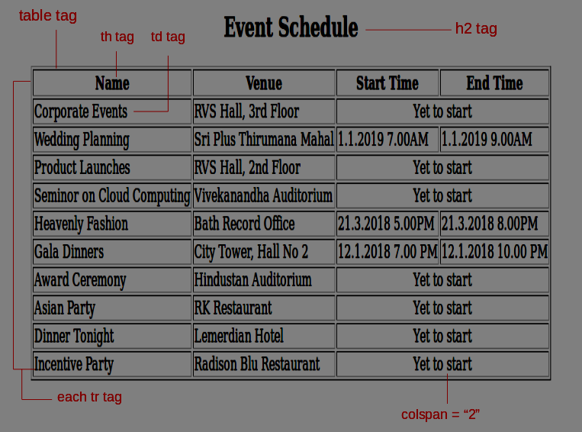

2. Tables - cellspacing & cellpadding

Great events are to be organized by Golden Petals for the public sectors like TATA Motors, Award function by BEA tv etc,. Ayush, the Chairman of this company wanted to review the list of events that are being planned for this year. The task to create an html page has been assigned to Manohar from the development team. The web page should display the list of events.

List of events should be displayed as a table format with spacing between the cells. To design the web page with spacing between cells, use cellspacing and cellpadding attributes. Help him to complete the task by creating an html webpage using the mentioned attributes.

Hints :

cellspacing

The cellspacing attribute specifies the space, in pixels, between cells.

Syntax :

<table cellspacing="10">

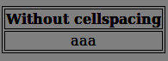

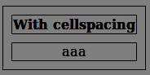

cellpadding

The cellpadding attribute specifies the space, in pixels, between the cell wall and the cell content.

Syntax :

<table cellpadding="10">

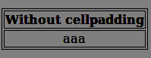

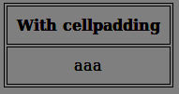

Content :

h1 tag - Event Schedule Table

|  |  |  |  |
| --- | --- | --- | --- |
| **Name** | **Venue** | **Start** | **End** |
| Corporate Events | RVS Hall, 3rd Floor | 1.1.2019 7.00AM | 1.1.2019 9.00AM |
| Wedding Planning | Sri Plus Thirumana Mahal | 13.1.2019 7.00AM | 13.1.2019 9.00AM |
| Gala Dinners | City Tower, Hall No 2 | 12.1.2018 7.00 PM | 12.1.2018 10.00 PM |
| Heavenly Fashion | Bath Record Office | 21.3.2018 5.00PM | 21.3.2018 8.00PM |
| Seminor on Cloud Computing | Vivekanandha Auditorium | 21.3.2018 5.00PM | 21.3.2018 8.00PM |
| Award Ceremony | Hindustan Auditorium | 1.3.2018 5.00PM | 1.3.2018 8.00PM |
| Asian Party | RK Restaurant | 12.3.2018 5.00PM | 12.3.2018 8.00PM |
| Dinner Tonight | Lemerdian Hotel | 20.4.2018 5.00PM | 20.4.2018 8.00PM |
| Incentive Party | Radison Blu Restaurant | 10.4.2018 5.00PM | 10.4.2018 8.00PM |
| Product Launches | RVS Hall, 2nd Floor | 1.3.2018 5.00PM | 1.3.2018 8.00PM |

Constraints :  
'table' tag should be used to design the html page.  
Create rows by using 'tr' tag.  
The first row represents the header in the table. It should be inside the 'th' tag.  
All the event specifications should be inside the'td' tag of the corresponding row.  
Use cellspacing and cellpadding value as "8" andborder property should be "1" in the table .   
  
Note :  
Web page should be displayed as shown in the screenshot.  
Kindly refer the content which is given as a part of the description  
  
Sample Screenshot 1 :

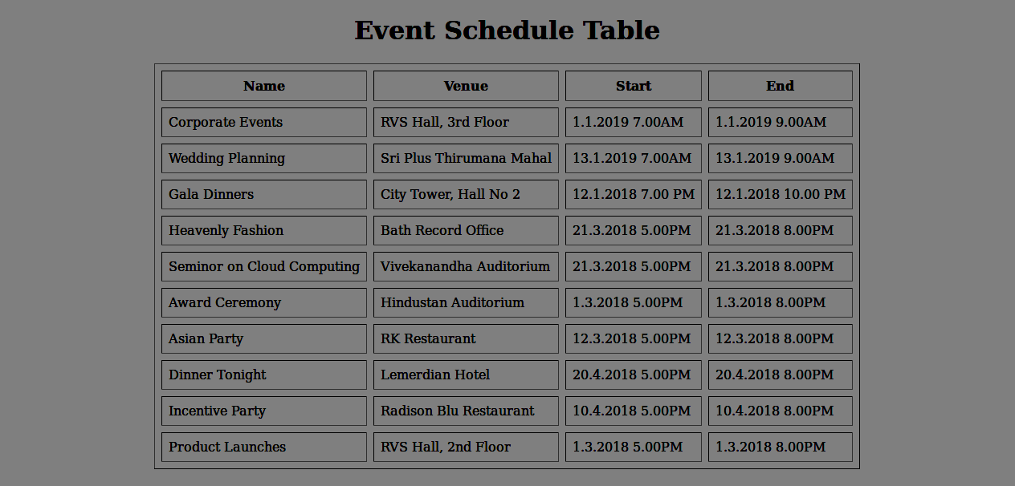  
  
Sample Screenshot 2 :

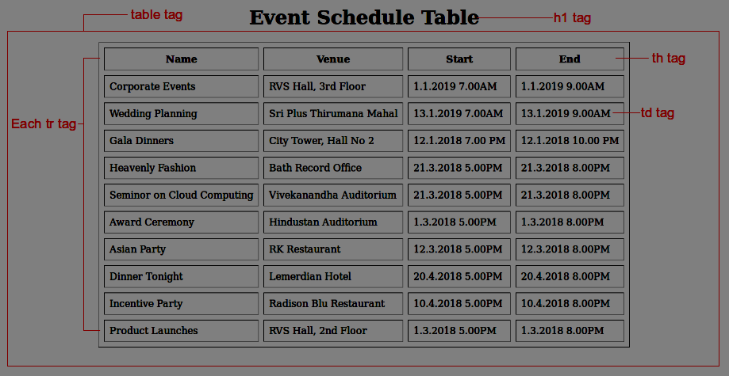

3.Tables - valign

Pink Frag Event Organization remains popular in managing events with a highly professional background. The company is in the business of creating experiences and their staunch belief is that an event may be forgotten, but an experience will last a lifetime. Great events are to be organized by the company for the public sectors. Ayush, the Chairman of this company wanted to review the list of events that are being planned for this year. Manohar, has been assigned the task to create an html page. The page should display the list of events in a table format with the details like name of the event and its detail, venue, start and end time of the event.  
  
In the process of creating the event schedule table, he wanted to make the details in each cell to be top aligned.  He needs your help to complete the task as required. Help him by creating an html page to display the details of scheduled events using valign attribute for top-aligning content.

Hints :

Attribute valign

The valign attribute specifies the vertical alignment of the content in a cell(Top-align content).

Syntax : <td valign="top">

Content :

h1 tag - Event Schedule Table

|  |  |  |  |  |
| --- | --- | --- | --- | --- |
| **Name** | **Detail** | **Venue** | **Start** | **End** |
| Corporate Events | Event Management of team building events that develop and motivate teams in companies and corporations. Team building events are perfect for companies and their divisions to motivate their employees and to develop real teams. | RVS Hall, 3rd Floor | 1.1.2019 7.00AM | 1.1.2019 9.00AM |
| Wedding Planning | We provide Wedding Event Management Service as per requirements of customers. These services are rendered by professionals who have several years of work experience. | Sri Plus Thirumana Mahal | 13.1.2019 7.00AM | 13.1.2019 9.00AM |
| Gala Dinners | Gala Dinner events can be held to celebrate, reward or engage an audience with a brand or service. Gala dinners also often involve the presentation of awards such as long service awards, sales person of the year, etc. | City Tower, Hall No 2 | 12.1.2018 7.00 PM | 12.1.2018 10.00 PM |
| Heavenly Fashion | A single platform for all the events where we organize Weddings, Birthday events, Engagement parties, Sangeeth, Anniversaries, Corporate events and mini parties along with best decorative themes that gives heavenly feel and a memorable time at the end of the event. | Bath Record Office | 21.3.2018 5.00PM | 21.3.2018 8.00PM |
| Seminar on Cloud Computing | Join the cloud computing event near you. Dreamforce conferences and Cloudforce events for business leaders featuring free demos, networking, share CRM ideas with peers and more at Salesforce India. | Vivekanandha Auditorium | 21.3.2018 5.00PM | 21.3.2018 8.00PM |
| Award Ceremony | Awards ceremonies are a celebration of talent, success and achievement, so when planning this kind of event, it's important that it's upbeat, exciting and well attended! We've pulled together some of the things you need to consider when organizing an awards ceremony. | Hindustan Auditorium | 1.3.2018 5.00PM | 1.3.2018 8.00PM |
| Asian Party | With our residents line-up, beautiful staff, and the best crowd in Amsterdam, John Doe has something for everyone. Listen to the best music under the huge led ceiling. | RK Restaurant | 12.3.2018 5.00PM | 12.3.2018 8.00PM |
| Dinner Tonight | The Dinner Tonight series is for beginning-to-intermediate level cooks who want to learn recipes that they can recreate at home. Students will prepare both simple weeknight recipes, and also dishes that can be made ahead of time for busy weeks. | Lemerdian Hotel | 20.4.2018 5.00PM | 20.4.2018 8.00PM |
| Incentive Party | An incentive program is a formal scheme used to promote or encourage specific actions or behavior by a specific group of people during a defined period of time. Incentive programs are particularly used in business management to motivate employees and in sales to attract and retain customers. | Radison Blu Restaurant | 10.4.2018 5.00PM | 10.4.2018 8.00PM |
| Product Launches | A launch event is an excellent way to showcase your latest product, build hype around it, and even acquire some sales right at the event. The more you can get people talking about the product, both at the event and via social media, the better it's going to do. | RVS Hall, 2nd Floor | 1.3.2018 5.00PM | 1.3.2018 8.00PM |

Constraints :  
 'table' tag should be used in the html page.  
Create rows by using 'tr' tag.  
The first row represents the header in the table. It should be inside the 'th' tag.  
All the event specifications should be inside the 'td' tag of the corresponding row.  
Use valign attribute for all 'td' tag and its value should be "top".  
  
Note :  
Web page should be displayed as shown in the screenshot.  
Kindly refer the content which is given as a part of description.  
  
Sample Screenshot 1 :  
  
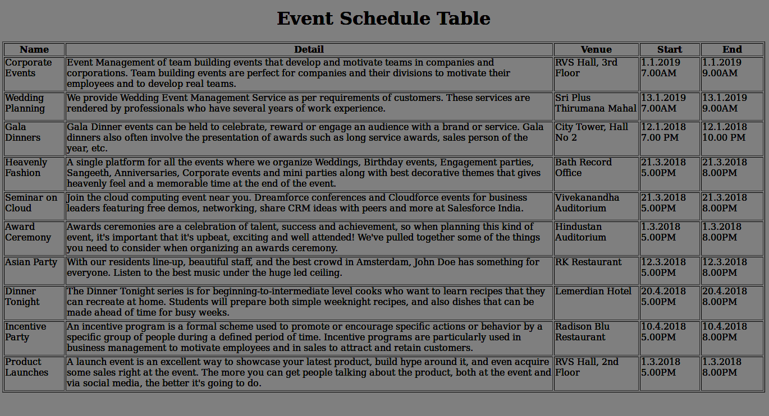  
  
Sample Screenshot 2 :  
  
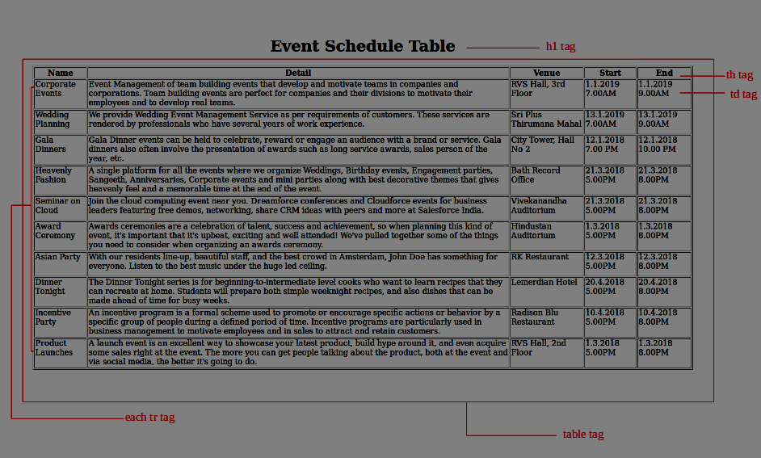

4. Tables - Image gallery

Pink Frag Event Organization is one of the Best Event Management Companies who organize and manage events that leave a lasting impression and project its perfection. They provide the leading event management services for birthday, wedding, corporate events and business conference. To make their business presence online, they have planned to create a webpage for their company. Zohon, the Manager of the company assigned Kiara to the company's website development. She planned to include many pictures related to the events on the website. But she was unable to include multiple pictures on the same page with proper grid alignment. She got an idea of using the table concept to create the grid alignment on the website, but she seeks your help in creating the webpage with multiple images.  
  
Create a sample webpage with multiple images using table tag with proper grid alignment for the Organization website.

Hints :

<table> tag

An HTML table consists of the <table> element and one or more <tr>, <th>, and <td> elements.

Syntax :

<table>

<tr>

<td>....</td>

</tr>

</table>

<img> tag

The <img> tag defines an image in an HTML page.

Syntax :

<img src = "xxx.jpg" >

Content :

h1 - Pink Frag Event Organizer

Images are given as a part of the template. Use it to design the web page  
  
Constraints :  
'table' tag should be used to design the html page.  
Create rows by using 'tr' tag.  
Table size should be 4 * 4.  
Each row must have 4 images.  
All the event specifications should be inside the'td' tag of the corresponding row.  
The ordering of images needs not to be placed in the same order which is shown in the screenshot.  
  
Note :  
Web page should be displayed as shown in the screenshot.  
Kindly refer the content which is given as a part of the description.  
  
Sample Screenshot 1 :

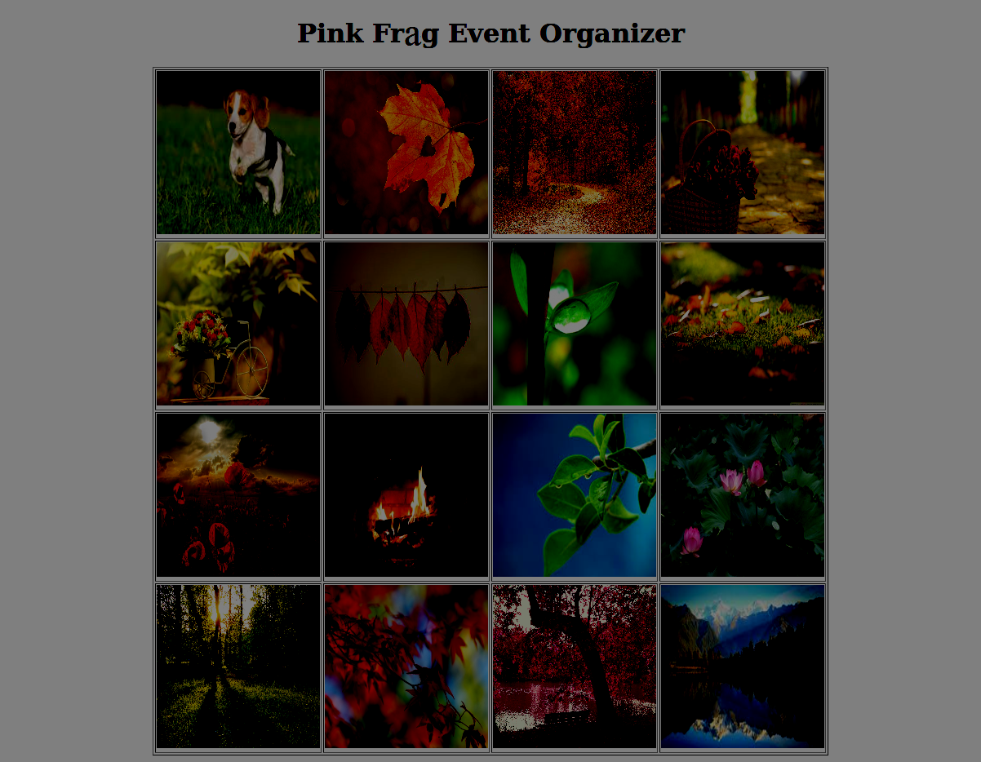  
  
Sample Screenshot 2 :

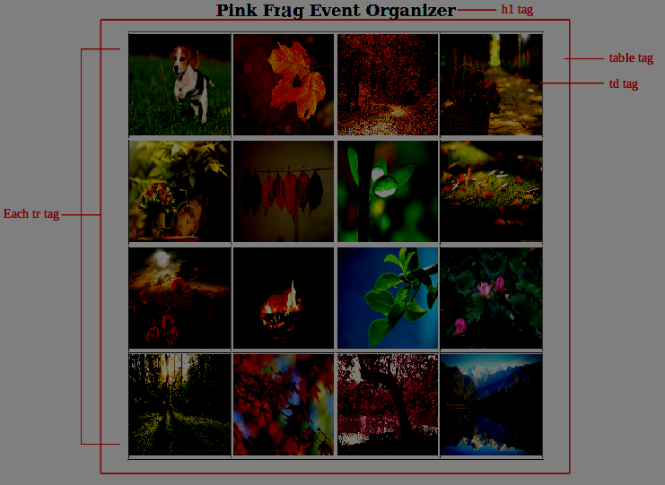

**5.CSS - styling tables**

Smith is a dynamic student who got so interested in web designing after attending Clinton's guest lecture. He practically coded few exercises and has successfully finished the task of styling the tables i.e, the headers and rows. Smith wanted to explore further on the internal stylings for tables and browsed through the internet.  
  
Understanding the concepts theoretically, he started to create a table structure in his sample webpage by trying out all the CSS declarations. But, he couldn't figure out the proper syntax for those declarations. Hence, he is in need of your help in completing the web page with creating a colorful table using CSS style tag .

**Hints :**

**table elements** The table selector is used to select the elements contained in the table. The th selector is used to select the header elements contained in the table.

The tr selector is used to select the rows contained in the table. The td selector is used to select the columns contained in the table.

Syntax :

<style>

table, td, th, tr {

CSS declarations

}

th

{

CSS declarations

}

</style>

**Content :**

|  |  |  |  |
| --- | --- | --- | --- |
| **Name** | **Venue** | **Start Time** | **End Time** |
| Wedding Planning | Sri Plus Thirumana Mahal | 4.5.2018 9.00AM | 4.5.2018 12.00PM |
| Corporate Events | RVS Hall, 2nd Floor | 6.9.2018 9.30AM | 6.9.2018 12.30PM |
| Award Ceremonies | Vivekanandha Auditorium | 6.1.2018 10.00AM | 6.1.2018 1.00PM |
| Gala Dinners | Paga Towers | 11.3.2018 9:30 AM | 11.3.2018 12:30 AM |

|  |
| --- |
|  |

|  |  |  |  |
| --- | --- | --- | --- |
| **Name** | **Venue** | **Start Time** | **End Time** |
| Promotion Party | Bath Record Office | 1.3.2018 9:30 AM | 1.3.2018 5:30 PM |
| Heavenly Fashion | RVM Hall | 21.01.2018 10:00 AM | 21.01.2018 1:00 PM |
| Incentive Party | Tower, Hall No 2 | 20.2.2018 4.30 PM | 20.2.2018 5:30 PM |
| Dinner Tonight | Hindustan Auditorium | 15.2.2018 4.30 PM | 15.2.2018 8.30 PM |

|  |  |  |  |
| --- | --- | --- | --- |
| **Name** | **Venue** | **Start Time** | **End Time** |
| Product Launches | Tower, Hall No 4 | 25.1.2018 2.30 PM | 25.1.2018 8.30 PM |
| Asian Party | Hindustan Auditorium | 15.4.2018 10.30 AM | 15.4.2018 2.30 PM |

**Constraints :**  
The index.html file must contain three tables.  
Apply the styles to table,th and td tag  
  
Table should have the border property  
 style- solid  
 width-1px  
 color-black  
  
th tag should have the background color  
color:#54cdc9  
  
td tag should have the font color  
color:#128cb9  
  
**Note :**  
The Web page should be present as shown in the screenshot.  
Kindly refer the content which is given as a part of description.  
Kindly don't change the template  
**Sample Screenshot 1:**  
  
  
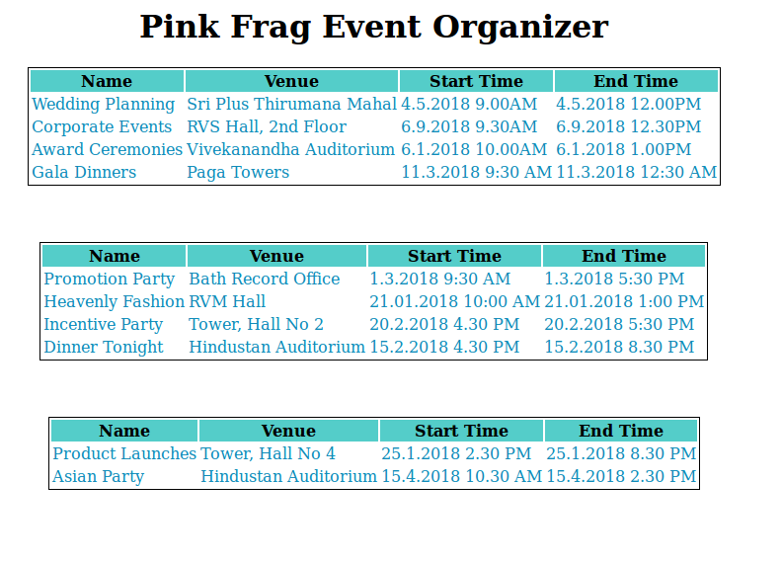  
  
**Sample Screenshot 2:**  
  
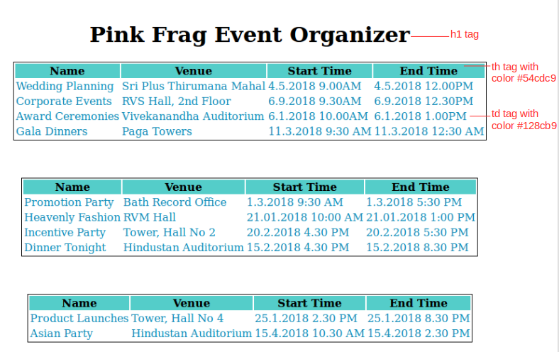

6.**PROBLEM**

**CSS - Striped tables using class & id**

Being an expert web designers, Nova and Kavin founded their own start-up company "YouGlobe Designs". As they progressed in getting more projects, the duo decided to expand their company's man power and posted few vacancies for Junior Web Developers on their official site.  
  
The company organized a recruitment drive at their campus and set an entry qualification for the job applicants that they should present an attractive web page with the constraints given to them. Sarah was one of those applicants who had great passion in the field. Her task is to create a web page with table structure containing alternative backgrounds using the class selector functionalities. Since Zaara has limited time to finish her task, help her create an HTML web page with table content using class selectors.

**Hints :**

**.class selector**  The .class selector selects elements with a specific class attribute. To select elements with a specific class, write a period (.) character, followed by the name of the class.

Syntax :

.class selector

{         CSS declarations

}

**Content :**

|  |  |  |  |
| --- | --- | --- | --- |
| **Name** | **Venue** | **Start Time** | **End Time** |
| Corporate Events | RVS Hall, 3rd Floor | 4.5.2018 9.00AM | 4.5.2018 12.00AM |
| Wedding Planning | Sri Plus Thirumana Mahal | 1.1.2019 7.00AM | 1.1.2019 9.00AM |
| Product Launches | RVS Hall, 2nd Floor | 4.5.2018 2.00PM | 4.5.2018 5.00PM |
| Seminor on Cloud Computing | Vivekanandha Auditorium | 18.12.2018 8.30AM | 18.12.2018 1.00PM |
| Heavenly Fashion | Bath Record Office | 21.3.2018 5.00PM | 21.3.2018 8.00PM |
| Gala Dinners | City Tower, Hall No 2 | 12.1.2018 7.00 PM | 12.1.2018 10.00 PM |
| Award Ceremony | Hindustan Auditorium | 11.11.2018 9.00 AM | 11.11.2018 5.00 PM |

**Constraints :**  
The file name should be index.html file.  
The class name for odd rows must be 'odd'.  
The class name for even rows must be 'even'.  
The background color of the class with name 'odd' must be '#b3edcf'.  
The background color of the class with name 'even' must be '#e0f0e9'.  
The table, tr and td must have the border with '1px solid black' and border-collapse as 'collapse' properties.  
Refer screenshots for more detailed specifications  
  
**Note :**  
The Web page should be present as shown in the screenshot.  
Kindly refer the content which is given as a part of description.  
Kindly Don't change the template  
  
**Sample Screenshot 1:  
  
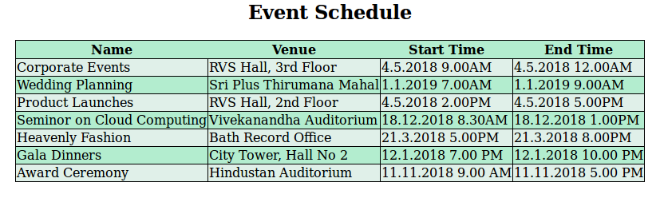  
  
Sample Screenshot 2:**  
  
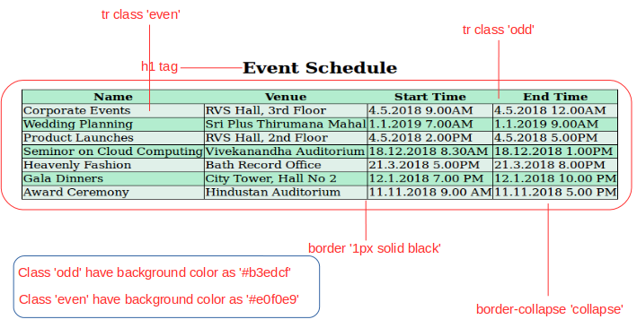

## 7.PROBLEM

**CSS - Responsive tables**

Hutch Event Services in Mumbai, being a successful event management organization, has organized many events in the City. Stacy, the web designer is the key person who has created the website for the company displaying the event schedule list. On testing the web page, Stacy resized the browser size by mistake which led to the missing of contents in the webpage.  
  
Hence, Stacy had to rework on the table properties of the HTML page to make the table visible for all resolutions of the browser. She requests your help to do the specified task on behalf of her. Write a program to create an html page using the overflow-x property on the table.

**Hints :**

**Responsive tables**

A responsive table will display a horizontal scroll bar if the screen is too small to display the full content.

To create a responsive table, add a container element with

overflow-x:auto around the <table>

**Content :**

|  |  |  |  |
| --- | --- | --- | --- |
| Name | Venue | Start Time | End Time |
| Corporate Events | RVS Hall, 3rd Floor | 14.03.2018 08.00AM | 14.03.2018 11.00AM |
| Wedding Planning | Sri Plus Thirumana Mahal | 01.01.2019 07.00AM | 01.01.2019 09.00AM |
| Product Launches | RVS Hall, 2nd Floor | 07.05.2018 08.00AM | 07.05.2018 11.00AM |
| Seminor on Cloud Computing | Vivekanandha Auditorium | 11.12.2018 07.00AM | 11.12.2018 11.00AM |
| Heavenly Fashion | Bath Record Office | 21.03.2018 05.00PM | 21.03.2018 08.00PM |
| Gala Dinners | City Tower, Hall No 2 | 12.01.2018 07.00 PM | 12.01.2018 10.00 PM |

Use table to display the content as shown below on resizing the brower.  
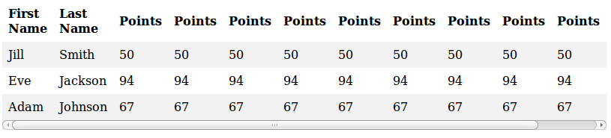

**Constraints :**  
The html page should contain a <div> tag.  
The div tag must be applied with styles inorder to create responsive table.  
Use Inline CSS   
**Note :**  
The webpage page should be present as shown in the screenshot.  
Kindly refer the content which is given as a part of description  
  
**Sample Screenshot 1:**  
  
**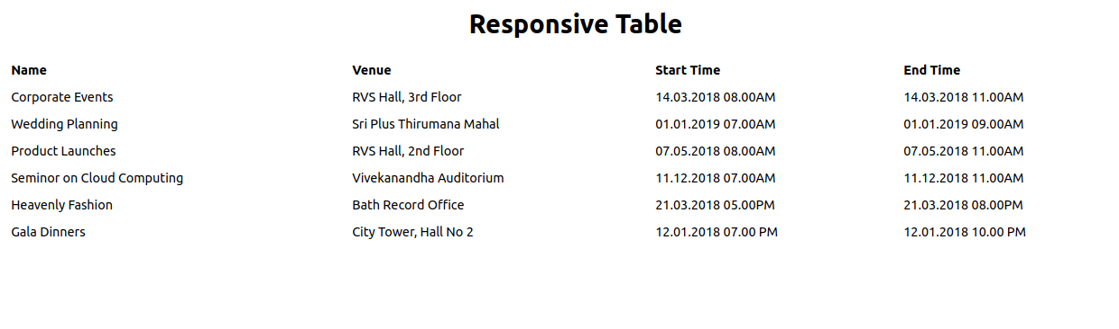  
  
Sample Screenshot 2:**

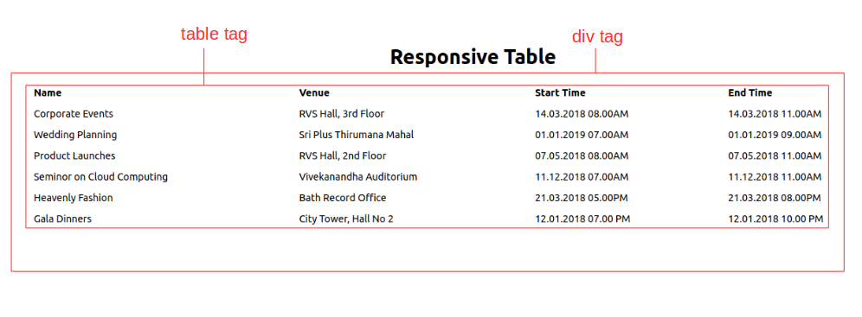

## 8.PROBLEM

**CSS Margins**

Krish has been a recently joined intern at Xioxi Techpark. Krish is interested in HTML & CSS concepts and is getting trained in the skill to get on the job. His first assessment of the training is to create an HTML page with table structure by applying different styles using margin property. The margin properties can be specified in four ways like top, bottom, right, left. Each property can hold specific values which will produce different alignment in the HTML page.  
Being a fresher, he might need help to develop the html code for the table using margin properties. Hence, create a webpage using the  margin property in CSS.

**Hints :**

**margin-top:** The margin-top property sets the top margin of an element.

Syntax :   margin-top: *length*|auto|initial|inherit;

**margin-bottom:** The margin-bottom property sets the bottom margin of an element.

Syntax :   margin-bottom: *length*|auto|initial|inherit;

**margin-right:** The margin-right property sets the right margin of an element.

Syntax :   margin-right: *length*|auto|initial|inherit;

**margin-left:** The margin-left property sets the left margin of an element.

Syntax :   margin-left: *length*|auto|initial|inherit;

**Content :**  
h1 - Event Schedule  
table class - table1  
first tr tag  
td - div class - div1  
A wedding planner is a professional who assists with the design, planning and management of a client's wedding  
td - div class - div2  
Social gathering is defined as interactions among a diversity of individuals of all abilities and community purposes.  
second tr tag  
td - div class - div3  
A corporate event can be defined as a gathering that is sponsored by a business for its employees, business partners, clients and/or prospective clients.  
td - div class - div4  
The debut of a product into the market. The product launch signifies the point at which consumers first have access to a new product  
  
Have direct margin values for the problem.  
Have a table with 2*2 matrix.  
Give background color for table with class name - table1.  
create a div with respective  class names inside each td tag  and give different background color.  
Give table  width = "600px"  and  height ="300px".  
For first div with class name div1 , margin-left  = "100px".  
For second div with class name div2 , margin-right  = "50px".  
For third div with class name div 3, margin-top = "50px".  
For fourth div with with class name div 4, margin-bottom = "100px".  
  
**Constraints :**  
Each <td> tag must contain a div tag with the mentioned class names.  
Apply the given margin style property for the each div tag as given in the content.  
  
**Note :**  
The Webpage should be present as shown in the screenshot.  
Kindly refer the content which is given as a part of description  
  
**Sample Screenshot 1:**  
  
Before applying margin style  
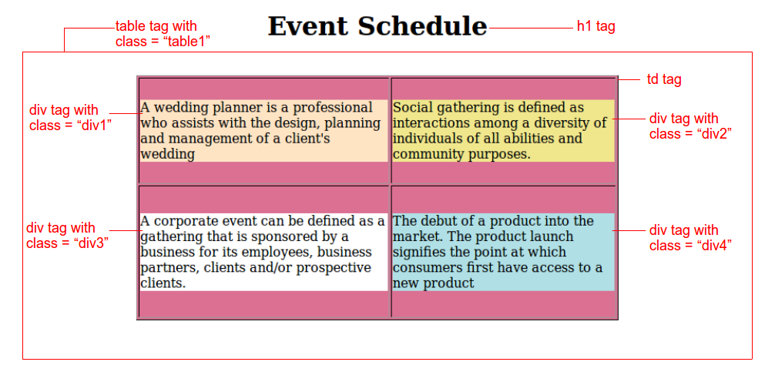  
  
**Sample Screenshot 2:**  
  
After applying margin style  
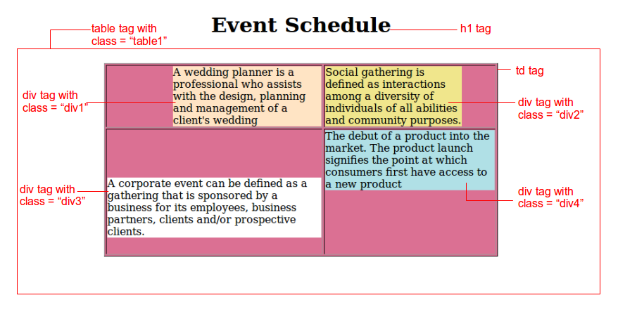

**9.PROBLEM**

**CSS - tables colgroup**

Clarie Clubhouse in Mumbai has successfully organized many events in the City. Charlie, a web designer is the key person who has created the web site for the company displaying the event schedule list. On reviewing the web page created by him, the Company felt that the page can be made a bit more attractive.  
Hence, Charlie wanted to rework on the CSS specifications of the HTML page to make it captivating by adding every column with different colors. So Charlie needs your help to do the specified task on behalf of him. Write a program to create an html page with the usage of colsgroup attribute in the table.

**Hints :**

**Tag <colgroup>**

The <colgroup> tag specifies a group of one or more columns in a table for formatting. The <colgroup> tag is useful for applying styles to entire columns, instead of repeating the styles for each cell, for each row. To define different properties to a column within a <colgroup>, use the <col> tag within the <colgroup> tag.

Syntax :

|  |  |  |  |  |  |  |
| --- | --- | --- | --- | --- | --- | --- |
| **Event Id** | **Name** | **Detail** | **Venue** | **Start Time** | **End Time** | **Number of Participants** |
| COE124 | Corporate Events | Event Management of team building events that develop and motivate teams in companies and corporations. | RVS Hall, 3rd Floor | 1.1.2019 7.00AM | 1.1.2019 9.00AM | 200 |
| WEP_456 | Wedding Planning | We provide Wedding Event Management Service as per requirements of customers. These services are rendered by professionals who have several years of work experience. | Sri Plus Thirumana Mahal | 13.1.2019 7.00AM | 13.1.2019 9.00AM | 1000 |
| DIN_896 | Gala Dinners | Gala Dinner events can be held to celebrate, reward or engage an audience with a brand or service.Gala dinners also often involve the presentation of awards such as long service awards, sales person of the year, etc. | City Tower, Hall No 2 | 12.1.2018 7.00 PM | 12.1.2018 10.00 PM | 500 |
| HEF_211 | Heavenly Fashion | A single platform for all the events where we organise Weddings,Birthdayevents,Engagement parties,and mini parties along with best decorative themes that gives heavenly feel and a memorable time at the end of the event. | eachBath Record Office | 21.3.2018 5.00PM | 21.3.2018 8.00PM | 2000 |
| SCD_110 | Seminor on Cloud Computing | Join the cloud computing event near you. Dreamforce conferences and Cloudforce events for business leaders featuring free demos, networking, share CRM ideas with peers and more at Salesforce India. | Vivekanandha Auditorium | 21.3.2018 5.00PM | 21.3.2018 8.00PM | 110 |
| ACM_189 | Award Ceremony | Awards ceremonies are a celebration of talent, success and achievement. We've pulled together some of the things you need to consider when organising an awards ceremony. | Hindustan Auditorium | 1.3.2018 5.00PM | 1.3.2018 8.00PM | 3000 |

<colgroup> <col> //css declarations* </colgroup>

**Content :**  
Content is given as a part of template  
Design the html page using table tag  
Assign each background color for each column  
**col style**  
First column has  background-color of #dbf9fc  
Second column has  background-color of #fcdbdb  
Third column has  background-color of #dcedeb  
Fourth column has  background-color of #eddce4  
col span - 2 for fifth and sixth column  
Fifth and sixth column has  background-color of #dcdced  
Seventh column has  background-color of #f5f7cd

**Constraints :**  
Design the html page as given in the sample screenshot1.  
Use Colgroup tag to give background color for the column.  
Combine the start and end time using col tag span attribute and use the same background color.  
  
**Note :**  
The Webpage should be displayed as shown in the screenshot.  
Kindly refer the content which is given as a part of description.

Don't change the template  
  
**Sample Screenshot 1:**  
  
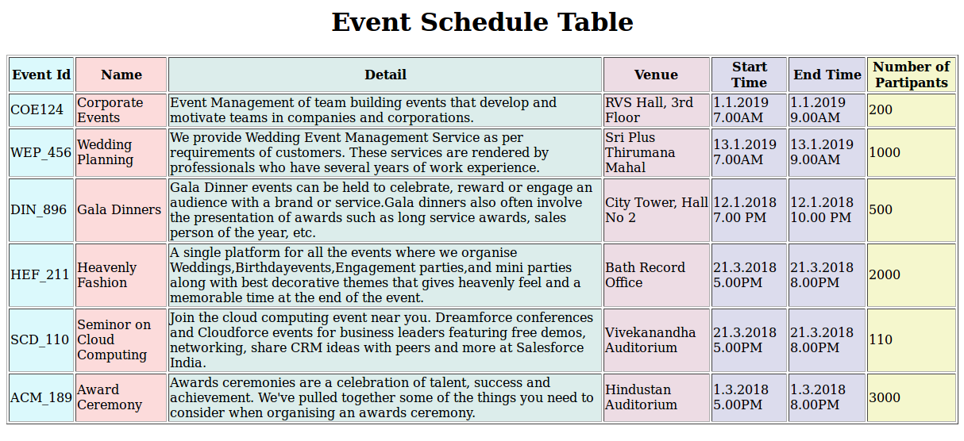  
  
**Sample Screenshot 2:**  
  
